Jenkins, Weston, and Hotchkiss, John B. (1898, January). Deaf Artists and Sculptors, Silent Worker, 10 (5), pg 65-69.

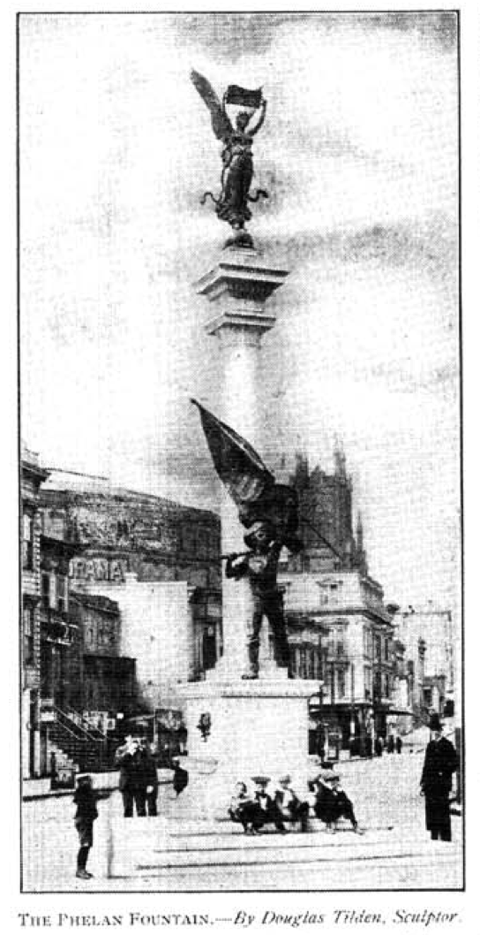

Poem below by Laura Redden (Searing)
