FROM THE MARYLAND BULLETIN
SEPTEMBER 1912 PAGE 5 VOL XXXIII (1)
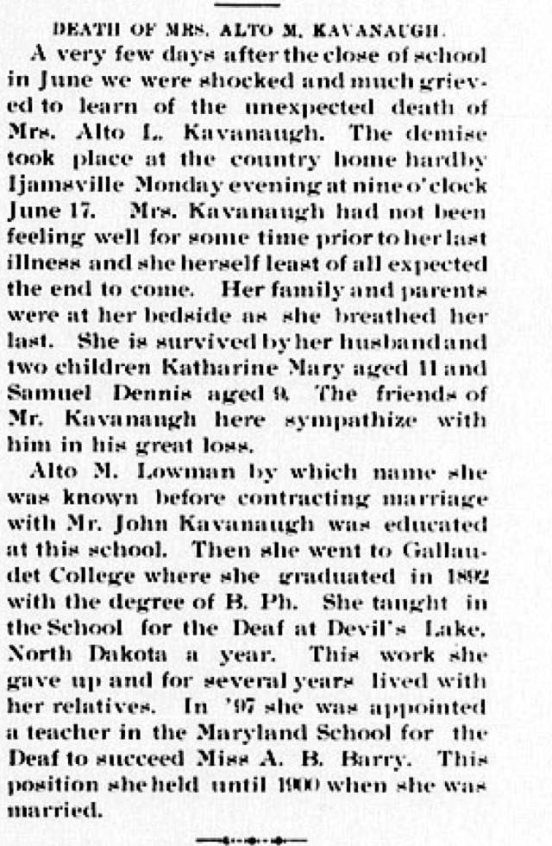
BELOW FROM MARYLAND BULLETIN 1900, OCTOBER PAGE 3 VOL. XXL (3)

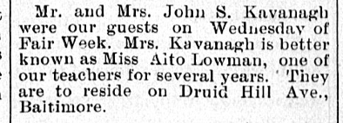

BELOW FROM MARYLAND BULLETIN
1900 JUNE PG 3 VOLXX (20)
